**1. Use the Previously Created Apache2 VM**

* Ensure that your **Apache2 VM** is running and accessible by its public IP address.

**2. Get a Free Domain from Freenom.com**

1. **Go to Freenom**:
   * Visit [freenom.com](https://www.freenom.com).
2. **Register a Domain**:
   * In the homepage search bar, enter the domain name you want to register.
   * Select one of the free domain extensions (.tk, .ml, .ga, .cf, .gq).
   * Click on “Get it Now,” then proceed by clicking on **Checkout**.
3. **Configure the Domain**:
   * Set the registration period (usually free for up to 12 months).
   * In the next step, choose **Use Freenom DNS Service** or **Use your own DNS**.
4. **Complete the Registration**:
   * Create an account or log in to your existing Freenom account.
   * Complete the checkout process, and you will receive a confirmation email once the domain is successfully registered.

**3. Use Azure DNS to Point the Domain to Your VM’s IP**

1. **Create an Azure DNS Zone**:
   * In **Azure Portal**, navigate to **DNS Zones**.
   * Click on **Create**.
   * Choose the same **resource group** as your VM and enter the domain name (e.g., yourdomain.tk).
   * Select the appropriate **subscription** and **resource group** for this DNS zone.
   * Click **Review + Create**, then **Create**.
2. **Get the Azure DNS Name Servers**:
   * After the DNS zone is created, open it, and you will see the **Name servers** (e.g., ns1-01.azure-dns.com, etc.).

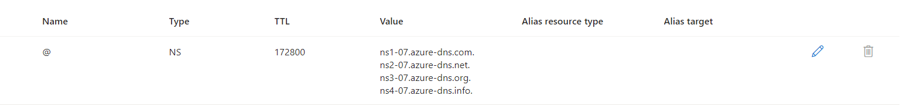

* + Copy these name servers as you'll need them for Freenom.

1. **Update Name Servers on Freenom**:
   * Log in to your **Freenom account**.
   * Go to **Services** > **My Domains** > **Manage Domain** > **Management Tools** > **Nameservers**.
   * Select **Use Custom Nameservers**, and input the Azure DNS nameservers copied from the Azure portal.
   * Click **Save Changes**.
2. **Create an A Record in Azure DNS**:
   * In the **Azure DNS Zone**, click on **+ Record set**.
   * Set the **Name** to @ (this represents the root domain).
   * Set the **Type** to A (for an A record).
   * Enter your **VM’s public IP** address in the **IP address** field.
   * Click **OK** to save the record.

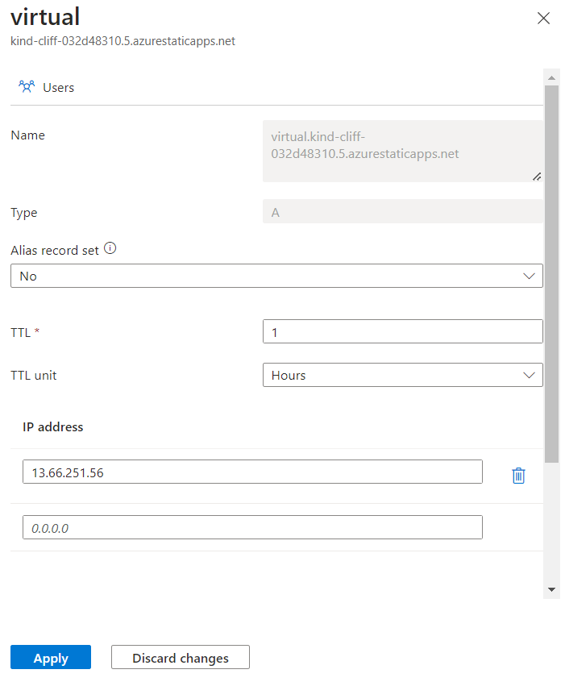

**4. Verify Domain Configuration**

* **Wait for DNS propagation**, which might take a few minutes to a couple of hours.
* Open a browser and visit your free domain (e.g., http://yourdomain.tk).